Weather, Drought, and Wildfires: Exploring the Relationship Across the Contiguous United States

Mark Spiker
Franklin University
DATA 605: Data Visualization and Reporting
Mohammad Abdel-Rahman
November 7, 2026

Weather, Drought, and Wildfires: Exploring the Relationship Across the Contiguous United States
Wildfires threaten lives, homes, air quality, natural resources, and communities across the United States (Steblein et al., 2019; U.S. Environmental Protection Agency [EPA], 2016). Weather and climate influence the conditions under which vegetation dries and burns; however, other factors, including fuel availability, land use, and management practices, also influence wildfire activity (EPA, 2016; National Oceanic and Atmospheric Administration [NOAA], n.d.). Research has demonstrated relationships among rising temperatures, drought conditions, fuel dryness, and wildfire activity, particularly in the western United States (NOAA, n.d.). Therefore, this study examines whether a correlation exists among changes in temperature, precipitation, and wildfire frequency over time. The study does not attempt to determine the causes of observed climate change. Rather, it evaluates changes in climate variables and their statistical relationship with wildfire frequency.
As illustrated in Figure 1, the Climate Map of the United States (Blue Green Atlas, n.d.) the lower 48 states encompass widely contrasting geographic and climate zones. For this reason, the contiguous 48 states were the focus of the research due to climate diversity. The country includes extensive mountain ranges, high plateaus, expansive plains and coastal areas. Differences in elevation, geography, and regional weather patterns contribute to this diversity. The Midwest experiences cold winters and warm summers with occasional heat waves, drought, snow and freezing rain. The Southeast is warmer and more humid with precipitation becoming more significant farther south. Hurricanes and tropical storms can also impact this region. The West has dramatic contrasts with elevation in the Rocky Mountains contributing to substantial climatic variation. The Pacific Northwest has mild winters, considerable rainfall and temperature variations that are smaller than the rest of the country. Finally, California has a Mediterranean climate with the mountains adding more variation. (Blue Green Atlas, n.d.) Collectively, these regional differences make the contiguous United States an appropriate study area for examining patterns across diverse climatic conditions and their relationship to wildfire activity.
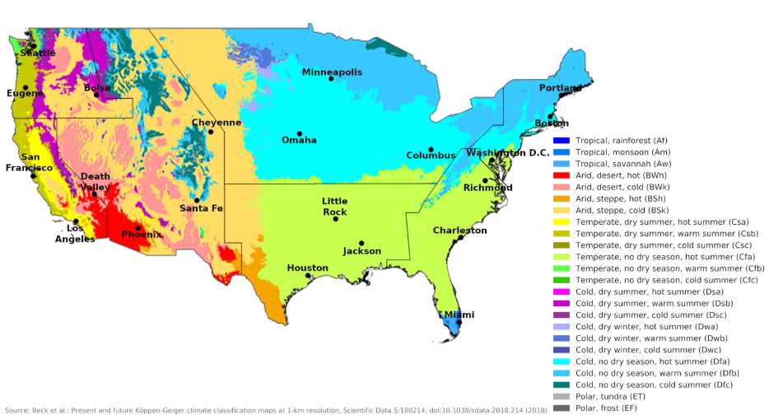
Figure 1 - Climate Map of the United States (Blue Green Atlas, n.d.)

Benefits of Research
Understanding the relationship between climate anomalies and wildfire activity provides critical intelligence for emergency management agencies, state foresters, and federal policymakers, enabling them to more effectively allocate preventative funding, reactive disaster response resources, and deployment assets. To make this correlation, the primary question becomes: how strongly do severe drought indicators and precipitation anomalies correlate with wildfire occurrences and total acreage burned across the contiguous United States? Secondly, it is important to understand if certain geographic regions show a higher vulnerability to multi-year drought cycles in terms of wildfire frequency compared to other regions?

Hypothesis
Primary Hypothesis: Regions experiencing prolonged severe-to-extreme drought conditions (demonstrated by negative Palmer Drought Severity Index values) combined with significant negative precipitation variances will exhibit a statistically significant increase in wildfire frequency and total acreage burned compared to regions with normal or surplus precipitation levels.

Secondary Hypothesis: Western states within the contiguous 48 states will display substantially higher vulnerability and scale of impact per drought index unit compared to Midwestern, Eastern, or Southern states, driven by baseline arid conditions and dominant volatile fuel types.

Datasets
This study used four distinct federal datasets to investigate the relationship between long-term drought, temperature fluctuations, precipitation patterns and wildfire occurrence across the contiguous United States. These datasets combine climate and wildfire data to allow for a comprehensive assessment of how environmental conditions are associated with wildfire susceptibility. Below are detailed descriptions of each dataset.

Drought Severity Data
- Source, Collection and Purpose: Monthly statewide Palmer Drought Severity Index (PDSI) data were obtained from NOAA Monthly U.S. Climate Divisional Database (Vose et al., 2014). The project was funded and collected by the National Oceanic and Atmospheric Administration (NOAA) to monitor long-term drought conditions across the United States.
- Timeline, Scope and Size: The data spans over 41-years (1984-2025), this dataset provides monthly PDSI observations across each state in the United States. There is one record per state per month.
- Variables: Variables include the continuous PDSI numeric value along with the drought category label. A Python script was used to extract the data and assign drought-category labels using the stated PDSI thresholds ranging from mild to extreme drought or extreme wet. A common key was calculated in the script to facilitate cross-dataset merging.
- Alignment with goals: This dataset will address questions associated with how moisture deficits correlate with increases in acreage burned in each state.

Precipitation Data
- Source, Collection and Purpose: Monthly statewide precipitation data were also obtained from NOAA Monthly U.S. Climate Divisional Database (Vose et al., 2014). Data funded and is collected by the National Oceanic and Atmospheric Administration (NOAA) to track short- and long-term moisture across states.
- Timeline, Scope and Size: The data spans over 41-years (1984-2025), this dataset provides monthly historical rainfall records across each state in the United States. There is one record per state per month.
- Variables: Variables include the actual and normal precipitation measured in inches along with the difference from normal. A Python script was used to automate data extraction. A common key was calculated in the script to facilitate cross-dataset merging.
- Alignment with goals: This dataset will address questions associated with how moisture deficits correlate with increases in acreage burned in each state.

Average Temperature Data
- Source, Collection and Purpose: Monthly statewide average temperature data were similarly obtained from NOAA Monthly U.S. Climate Divisional Database (Vose et al., 2014). Data is funded and collected by the National Oceanic and Atmospheric Administration (NOAA) to track average temperature driving surface evaporation.
- Timeline, Scope and Size: The data spans over 41-years (1984-2025), this dataset provides monthly historical average temperature across each state in the United States. There is one record per state per month.
- Variables: Variables include the average and normal temperature (degrees F) with the difference from normal. A Python script was used to automate data extraction. A common key was calculated in the script to facilitate cross-dataset merging.
- Alignment with goals: This dataset will address questions associated with how temperature correlates with increases in acreage burned in each state indicating an increase in evaporation rate.

Wildfire Occurrence Data
- Source, Collection and Purpose: Wildfire occurrence records and recorded acres burned for the years 1992 through 2024 were obtained from the U.S. Department of Agriculture (U.S. Department of Agriculture, Forest Service, n.d.). The dataset contains historical fire reporting across federal, state, and private lands for forestry management and disaster mitigation research.
- Timeline, Scope and Size: The data spans from 1992 to 2024 and is summarized at a state-by-month level. There is one record per state per month.
- Variables: Key variables include the number of wildfire incidents and number of acres burned. A Python script was used to automate data extraction. A common key was calculated in the script to facilitate cross-dataset merging.
- Alignment with goals: These records serve as the primary dependent variable for this study, allowing for direct statistical and visual comparisons against the NOAA climate variables to test whether specific drought and temperature thresholds trigger surges in burned acreage.

Dataset Limitations
While these federal datasets offer a rich historical insight, there are several limitations which must be called out concerning the use in the study:
- The climate data extends from 1984 to 2025, where the USDA wildfire records span from 1992 to 2024. As a result, comparative analysis and visualizations will be restricted to the overlapping window between 1992 to 2024.
- Because all data in this study are aggregating the data at the statewide level, local climates are smoothed out, potentially masking severe local anomalies at the county specific level.
- Other variables may not be factored in and could have a compelling impact and role in the association of wildfire events, these include land management practices, ignition sources (lightning vs. cigarette).

Data Story
To investigate how long-term environmental factors like temperature, precipitation and drought impact wildfire activity, this section presents several compelling visualizations to support and ultimately prove or disprove our hypothesis. In our Tableau Visuals file, it contains the U.S. Wildfire Risk & Climate Dynamics Dashboard, this dashboard incorporates five key visuals that test the correlation of wildfire incidents to PDSI and temperature departure from normal, illustrates total acres burned geographically, studies the correlation of burned acreage to drought or wet conditions and finally provides a summary by state of key climate and wildfire indicators. Below we will discuss the findings of each visualization.

Total Acres Burned with Temperature Departure
The map in Figure 2 represents cumulative wildfire acreage burned from 1992-2025 using an orange to brown gradient, then displays the temperature departure from normal for each state. Data was sourced from USDA Forest Service wildfire records with NOAA temperature records. The distribution of wildfires clearly demonstrates that the Western states are the most vulnerable with the most concentration of acres burned in that region. In contrast, Midwestern and Eastern states experience a much lower cumulative acreage burned. While California only experienced a small temperature departure, Texas experienced a much cooler departure with almost 20 degrees F below normal in the study period.
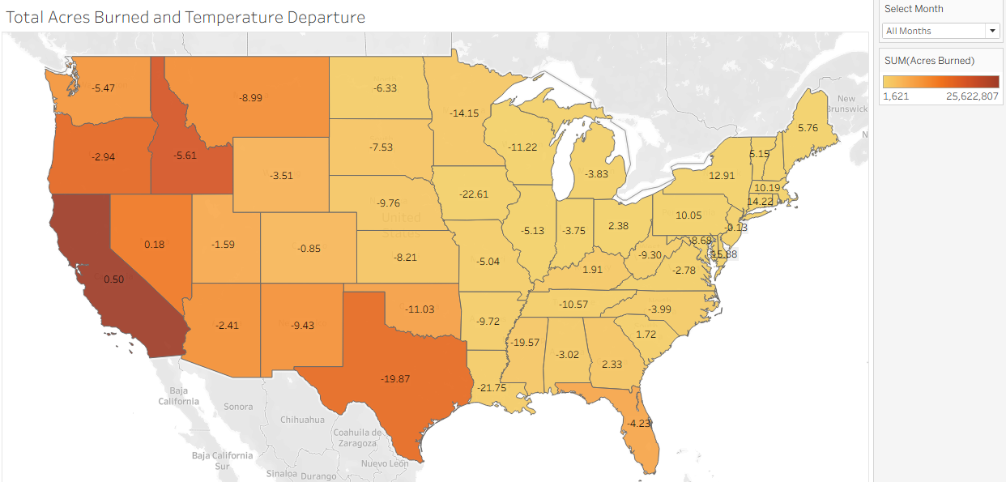
Figure 2 - Total Acres Burned and Temperature Departure

Total Incidents by Drought Category with Average Temp Departure
This vertical bar chart shown in Figure 3 examines the relationship between moisture condition and temperature departure. The chart measures total wildfire incidents on the vertical axis against categorical drought levels on the horizontal axis, with data labels showing the average temperature departures. Data was compiled from USDA wildfire records and NOAA Palmer Drought Severity Index records. The findings show that while mild and moderate drought conditions have the most wildfire incidents the highest variance in temperature is observed in states with severe to extreme drought conditions, thus supporting the fact that temperature plays a role in wildfire incidents.
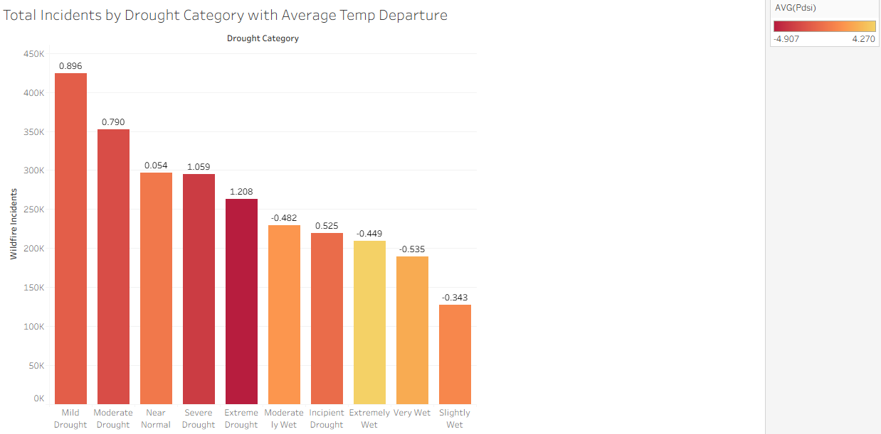
Figure 3 - Total Incidents by Drought Category with Average Temp Departure

Multi-Decadal Trends in Temperature Anomalies and Wildfire Acreage

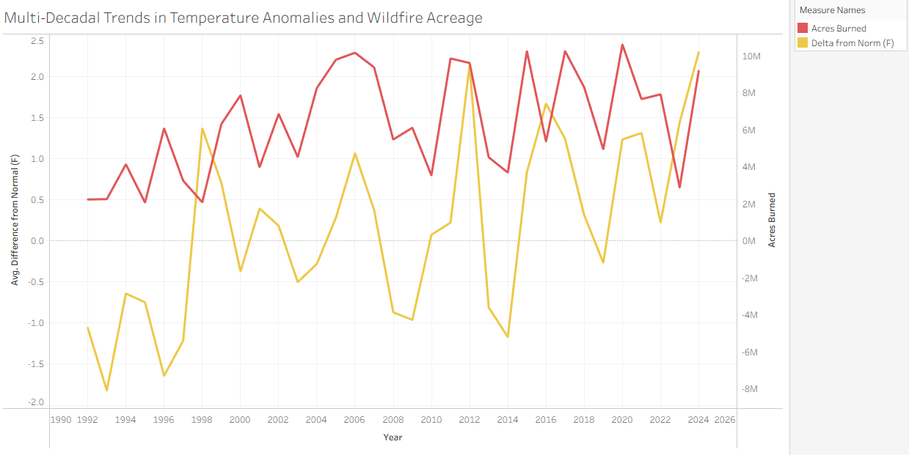
Figure 4 - Multi-Decadal Trends in Temperature Anomalies and Wildfire Acreage

Wildfire Incidents Correlation to PDSI

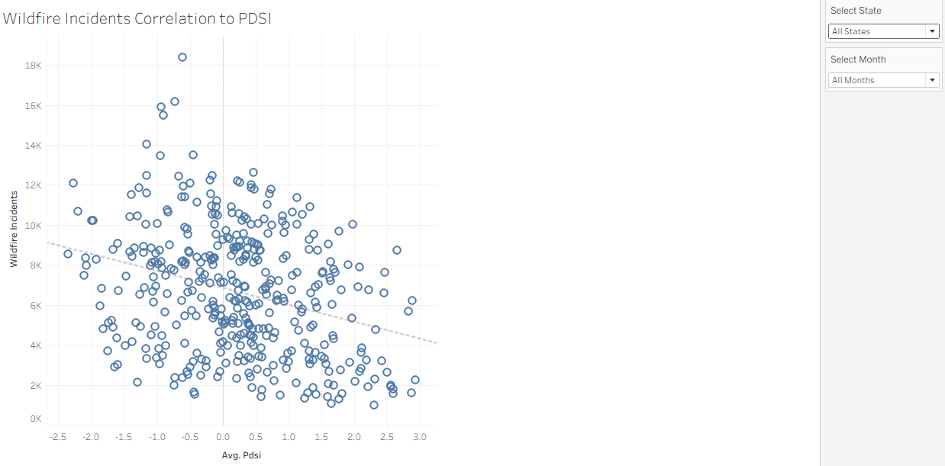
Figure 5 - Wildfire Incidents Correlation to PDSI

Wildfire Incidents Correlation to Temperature Departure

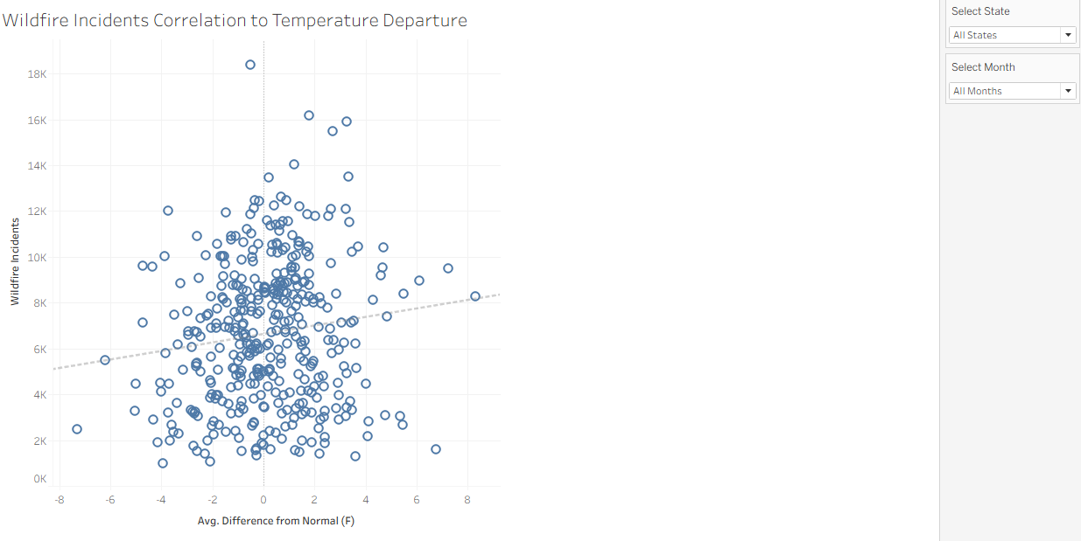
Figure 6 - Wildfire Incidents Correlation to Temperature Departure

Total Acres Burned by Drought Segment

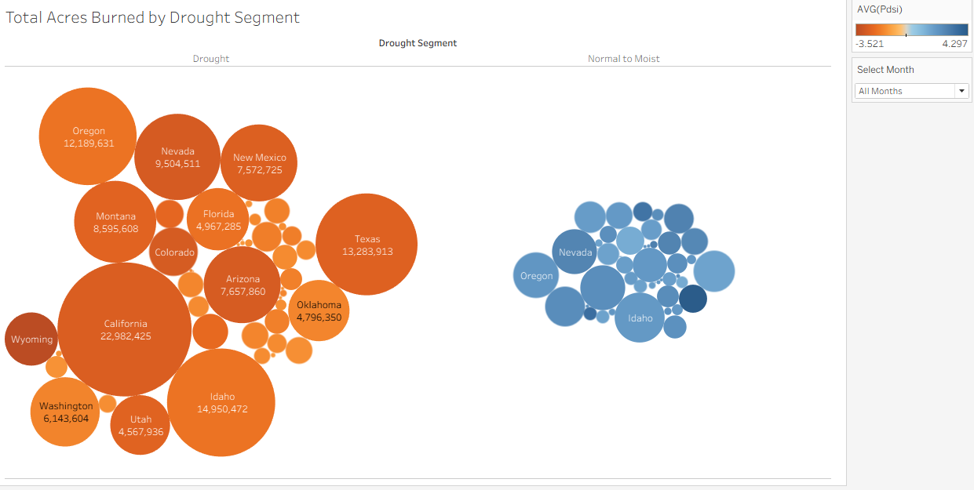
Figure 7 - Total Acres Burned by Drought Segment

Summary of Climate and Wildfire Incidents

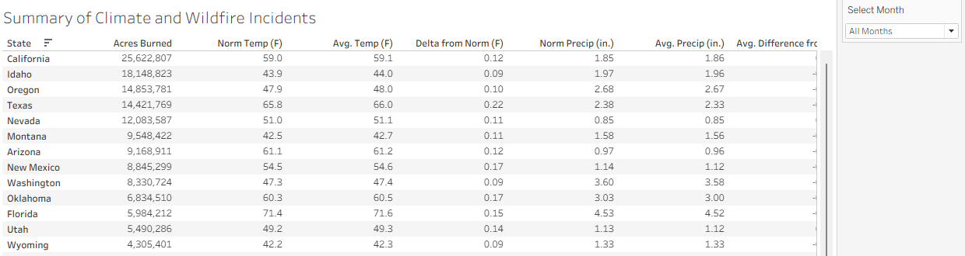
Figure 8 - Summary of Climate and Wildfire Incidents

Summary and Conclusion
Summary and Conclusions
Summarize your findings, explaining how your charts helped answer your questions in the introduction. Reflect on
your original hypotheses and explain how your analysis and visualizations supported them or how they provided a
different conclusion than anticipated. Evaluate the effect of any limitations in the dataset(s), or in your analysis

References
Blue Green Atlas. (n.d.). The climate of the United States of America. https://www.bluegreenatlas.com/climate/united_states_of_america_climate.html?
National Oceanic and Atmospheric Administration. (n.d.). Wildfire climate connection. https://www.noaa.gov/noaa-wildfire/wildfire-climate-connection
Steblein, P. F., Miller, M. P., & Soileau, S. C. (2019). Wildland fire science: Supporting wildland fire and land management (Fact Sheet 2019–3025). U.S. Geological Survey. https://doi.org/10.3133/fs20193025
U.S. Environmental Protection Agency. (2016). Climate change indicators in the United States, 2016 (4th ed., EPA 430-R-16-004). https://www.epa.gov/sites/default/files/2016-08/documents/climate_indicators_2016.pdf
Vose, R. S., Applequist, S., Squires, M., Durre, I., Menne, M. J., Williams, C. N., Jr., Fenimore, C., Gleason, K., & Arndt, D. (2014). NOAA monthly U.S. climate divisional database (NClimDiv). NOAA National Climatic Data Center. https://doi.org/10.7289/V5M32STR
U.S. Department of Agriculture, Forest Service. (n.d.). Fire occurrence (current edition) [Data set: State-by-month wildfire incident counts and acres burned, 1992–2024]. ArcGIS REST Services Directory. https://apps.fs.usda.gov/arcx/rest/services/EDW/EDW_FireOccurrenceCurrentEdition_01/MapServer/0

